Billy Guide to CSS Flexbox

display: flex; = turns an element into a flex container. This makes it possible to align any children of that element into rows or columns. You do this by adding flex-direction property to the parent item and setting it a row or column. Creating a row will align the children horizontally, and creating a column will align the children vertically.

Other options for flex-direction are row-reverse and column-reverse.

Note: The default value for the flex-direction property is row.

flex-direction: row;
flex-direction: column;

justify-content = defines how the browser distributes space between and around content items along the main-axis of a flex container, and the inline axis of a gris container.

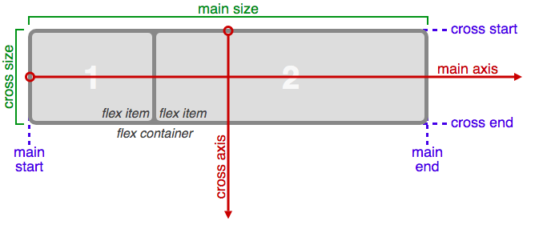
justify-content: ….
- center; = which aligns all the flex items to the center inside the flex container.
- flex-start: = aligns items to the start of the flex container. For a row, this pushes the items to the left of the container. For a column, this pushes the items to the top of the container. This is the default alignment if no justify-content is specified.
- flex-end: = aligns items to the end of the flex container. For a row, this pushes the items to the right of the container. For a column, this pushes the items to the bottom of the container.
- space-between: = aligns items to the center of the main axis, with extra space placed between the items. The first and last items are pushed to the very edge of the flex container. For example, in a row the first item is against the left side of the container, the last item is against the right side of the container, then the remaining space is distributed evenly among the other items.
- space-around: = similar to space-between but the first and last items are not locked to the edges of the container, the space is distributed around all the items with a half space on either end of the flex container.
- space-evenly: = Distributes space evenly between the flex items with a full space at either end of the flex container

align-items: = aligns flex items along the cross axis. For a row, it tells CSS how to push the items in the entire row up or down within the container. And for a column, how to push all the items left or right within the container.

align-items: ….
- flex-start = aligns items to the start of the flex container. For rows, this aligns items to the top of the container. For columns, this aligns items to the left of the container.
- flex-end = aligns items to the end of the flex container. For rows, this aligns items to the bottom of the container. For columns, this aligns items to the right of the container.
- center = align items to the center. For rows, this vertically aligns items (equal space above and below the items). For columns, this horizontally aligns them (equal space to the left and right of the items).
- stretch = stretch the items to fill the flex container. For example, rows items are stretched to fill the flex container top-to-bottom. This is the default value if no align-items value is specified.
- baseline = align items to their baselines. Baseline is a text concept, think of it as the line that the letters sit on.

flex-wrap: = moves items into a new row or column. The break point of where the wrapping happens depends on the size of the items and the size of the container.

flex-wrap: ….
- nowrap = this is the default setting, and does not wrap items.
- wrap = wraps items from left-to-right if they are in a row, or top-to-bottom if they are in a column.
- wrap-reverse = wraps items from right-to-left if they are in a row, or bottom-to-top if they are in a column.

flex-shrink = allows an item to shrink if the flex container is too small. Items shrink when the width of the parent container is smaller than the combined widths of all the flex items within it.
flex.shrink uses numbers as values, the higher the number, the more it will shrink compared to other items in the container ex. if item a has a flex-shrink of 1, and item b has a flex-shrink of 3, item b will shrink three times as much as item a.

flex-grow = the opposite of flex-shrink, controls the size of items when parent container expands. flex-grow also uses numbers as values in the same way as flex-shrink.

flex-basis = specifies the initial size of the item before CSS makes adjustments. Uses same units as other size properties (px, em, %. etc.) The value auto sizes items based on the content.

flex = shortcut to use several flex properties at once. written as:
flex: 1 0 10px; this means the item will be set to flex-grow = 1, flex-shrink = 0, and flex-basis = 150 pixels.

order = tells CSS the order of how flex items appear in the flex container. By default, items will appear in the same order the come in the source HTML. This property uses numbers and negative numbers as values.

align-self = allows each items alignment to be adjusted individually, instead of setting them all at once. Accepts the same values as align-items.

